



Enterprise Content Management apps in SharePoint 2013 and SharePoint Online solution pack (Module 5 of 8)

Microsoft Corporation

November 2014

**Applies to:** SharePoint 2013 and SharePoint Online

**Summary:** This solution pack includes code and documents that demonstrate and describe techniques that use enterprise content management features in SharePoint 2013 and SharePoint Online that can be delivered using apps.

©2014 Microsoft Corporation. All rights reserved.

This document is provided "as-is." Information and views expressed in this document, including URL and other Internet website references, may change without notice. You bear the risk of using it.

Some examples are for illustration only and are fictitious. No real association is intended or inferred.

This document does not provide you with any legal rights to any intellectual property in any Microsoft product. You may copy and use this document for your internal, reference purposes. You may modify this document for your internal, reference purposes.

# Contents

The Enterprise Content Management apps in SharePoint 2013 and SharePoint Online solution pack contains eight modules, which are listed in Table 1.

**Table 1. Enterprise Content Management apps in SharePoint 2013 and SharePoint Online solution pack modules**

|  |  |  |
| --- | --- | --- |
| **Module** | **Name** | **Describes how to…** |
| 1 | Document library templates | Implement a custom document library template when creating a document library. This sample describes how to use site columns, site content types, taxonomy fields, and version settings, and how to remove the default document content type from a document library. |
| 2 | Document auto tagging | Automatically tag documents with metadata when documents are created or uploaded to SharePoint. This sample describes creation of taxonomy fields and content types, creation of document libraries with content types, registration of the ItemAdding and ItemAdded Remote Event Receiver, removal of Remote Event Receivers, retrieval of User Profile properties, and setting of taxonomy fields. |
| 3 | Information Management | Get or set site policies to manage the site lifecycle (closure and deletion of sites after a period of time). |
| 4 | Records management extensions | Enable and change in-place records management settings on your sites and lists. |
| **5** | **Taxonomy operations** | **Create and read taxonomy data.** |
| 6 | Bulk uploading documents | Bulk upload documents to document libraries (including OneDrive for Business). |
| 7 | Upload large files | Use different methods to upload large files to a document library. |
| 8 | Synchronize term groups | Synchronize term groups across multiple term stores. |

# [Core.MMS app](https://github.com/OfficeDev/PnP/tree/dev/Samples/Core.MMS)

|  |  |  |
| --- | --- | --- |
| **What this demonstrates** | **Why you would want to use this sample** | **How this app works** |
| This sample console application demonstrates how you can interact with the Managed Metadata Service in SharePoint Server 2013 or SharePoint Online to create and read terms, term sets, and groups.  Note: this code will also run in a provider hosted app, such as an ASP.Net MVC web application. | Consider using this sample when migrating terms between SharePoint farms or displaying terms in your custom app. | This app runs as a console application using the Taxonomy client side object model. The app performs the following functions:   * Creates groups, term sets, and terms in the Managed Metadata Service. * Retrieves groups, term sets and terms stored in the Managed Metadata Service.   Important: ensure the user running this code sample has appropriate permissions to the Term Store. |

**Related samples**:

[Core.DevPnPCore](https://github.com/OfficeDev/PnP/tree/dev/OfficeDevPnP.Core)

[Core.MMSSync](https://github.com/OfficeDev/PnP/tree/dev/Samples/Core.MMSSync)

[Core.ContentTypesAndFields](https://github.com/OfficeDev/PnP/tree/dev/Scenarios/Core.ContentTypesAndFields)

**Before you run this app, make sure that you have:**

* The URL of your SharePoint site.
* Credentials with sufficient permissions to access the Term Store in the Managed Metadata Service. Figure 1 shows the Office 365 Admin Center where your Office 365 administrator can assign these permissions.

**Figure 1. Assign user permissions to the Term Store in the Office 365 Admin Center**

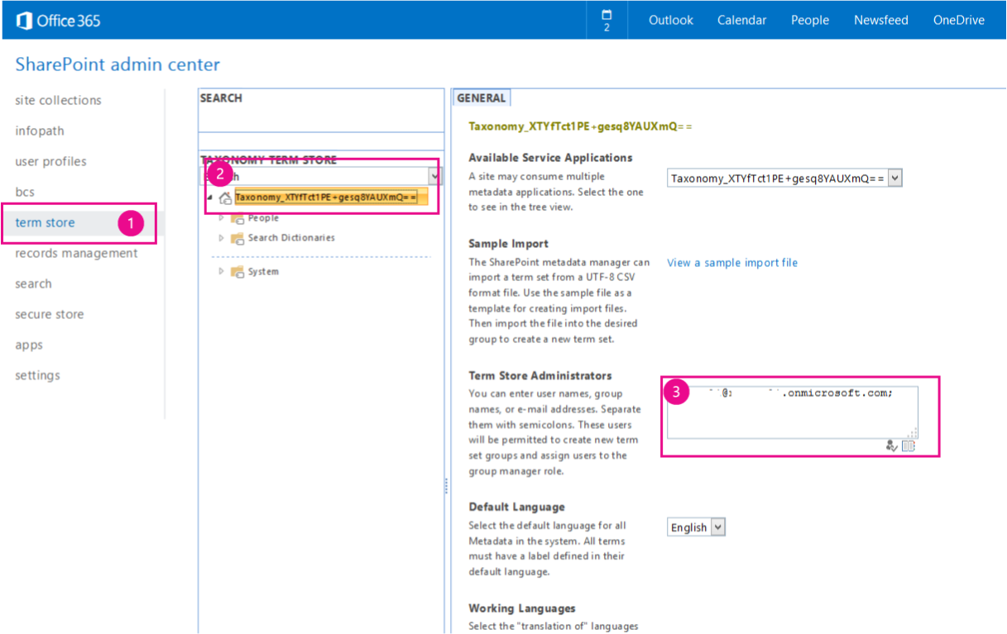

When you start the app, you see a console application similar to the one shown in Figure 2. You will be prompted to enter the URL of your SharePoint Server 2013 or SharePoint Online site and your credentials.

**Figure 2. Core.MMS console application**

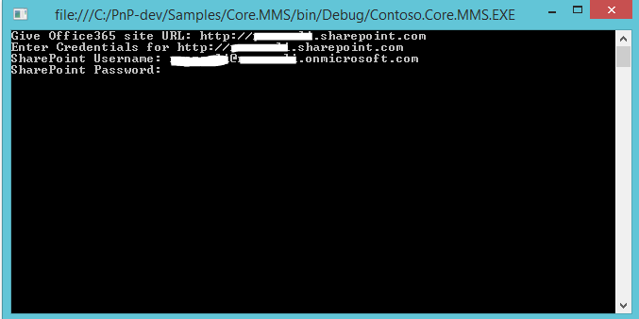

In the **Main** method of the **Program.cs** file, after you supply the URL of the SharePoint site and your credentials, user authentication occurs. The following code performs user authentication in SharePoint Online.

ClientContext cc = new ClientContext(siteUrl);

cc.AuthenticationMode = ClientAuthenticationMode.Default;

//For SharePoint Online

cc.Credentials = new SharePointOnlineCredentials(userName, pwd);

The following code performs user authentication in SharePoint Online Dedicated or in an on-premises SharePoint Server 2013 farm.

ClientContext cc = new ClientContext(siteUrl);

cc.AuthenticationMode = ClientAuthenticationMode.Default;

//For SharePoint Online Dedicated or on-premises

cc.Credentials = new NetworkCredential(userName, pwd);

The **CreateNecessaryMMSTermsToCloud** method creates a group, term set, and several terms in the Managed Metadata Service. The code first gets a reference to the TaxonomySession object, then the TermStore object, before creating the custom TermGroup, TermSet, and new terms.

private static void CreateNecessaryMMSTermsToCloud(ClientContext cc)

{

// Get access to taxonomy CSOM.

TaxonomySession taxonomySession = TaxonomySession.GetTaxonomySession(cc);

cc.Load(taxonomySession);

cc.ExecuteQuery();

if (taxonomySession != null)

{

TermStore termStore = taxonomySession.GetDefaultSiteCollectionTermStore();

if (termStore != null)

{

//

// Create group, termset, and terms.

//

TermGroup myGroup = termStore.CreateGroup("Custom", Guid.NewGuid());

TermSet myTermSet = myGroup.CreateTermSet("Colors", Guid.NewGuid(), 1033);

myTermSet.CreateTerm("Red", 1033, Guid.NewGuid());

myTermSet.CreateTerm("Orange", 1033, Guid.NewGuid());

myTermSet.CreateTerm("Yellow", 1033, Guid.NewGuid());

myTermSet.CreateTerm("Green", 1033, Guid.NewGuid());

myTermSet.CreateTerm("Blue", 1033, Guid.NewGuid());

myTermSet.CreateTerm("Purple", 1033, Guid.NewGuid());

cc.ExecuteQuery();

}

}

}

After creating the new terms, the **GetMMSTermsFromCloud()** method retrieves all term groups, term sets, and terms from the Managed Metadata service. Similar to the **CreateNecessaryMMSTermsToCloud()** method, the code first gets a reference to the TaxonomySession object, then the TermStore object, before retrieving and displaying the term information.

private static void GetMMSTermsFromCloud(ClientContext cc)

{

//

// Load up the taxonomy item names.

//

TaxonomySession taxonomySession = TaxonomySession.GetTaxonomySession(cc);

TermStore termStore = taxonomySession.GetDefaultSiteCollectionTermStore();

cc.Load(termStore,

store => store.Name,

store => store.Groups.Include(

group => group.Name,

group => group.TermSets.Include(

termSet => termSet.Name,

termSet => termSet.Terms.Include(

term => term.Name)

)

)

);

cc.ExecuteQuery();

//

// Writes the taxonomy item names.

//

if (taxonomySession != null)

{

if (termStore != null)

{

foreach (TermGroup group in termStore.Groups)

{

Console.WriteLine("Group " + group.Name);

foreach (TermSet termSet in group.TermSets)

{

Console.WriteLine("TermSet " + termSet.Name);

foreach (Term term in termSet.Terms)

{

// Writes root-level terms only.

Console.WriteLine("Term " + term.Name);

}

}

}

}

}

}

You will see your term data from your Managed Metadata Service displayed in the console application (Figure 3) and in the Term Store in your Managed Metadata Service (Figure 4).

**Figure 3. Console application showing Groups, TermSets, and Terms in the Managed Metadata Service**

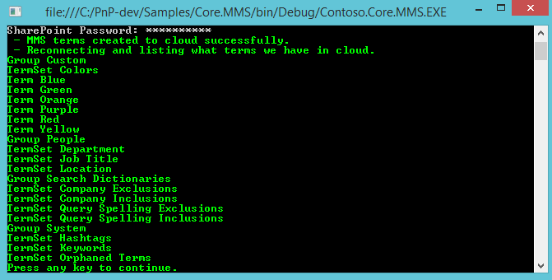

**Figure 4. Office 365 Admin Center showing Groups, TermSets, and Terms in the Managed Metadata Service**

